We use Ongoing WMS
Be a part of a great community. Ongoing WMS is the most used warehouse cloud service in Northern Europe. Read below about how our clients benefit from us using Ongoing WMS:
Connect your sales channels
We can easily and cost-effectively connect your sales channels thanks to Ongoing’s large ecosystem of related software solutions. See if your sales channel is integrated with Ongoing WMS.
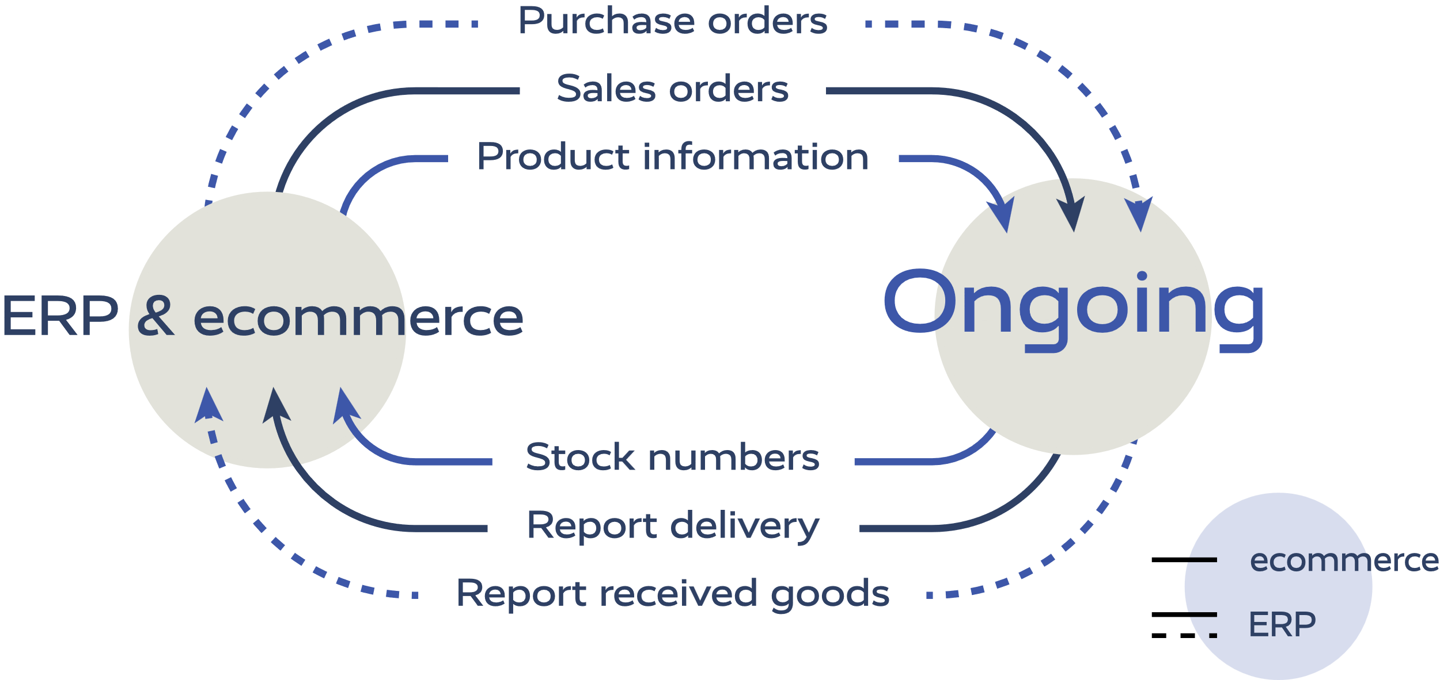

With Ongoing’s powerful and well-documented APIs, you can also build custom software solutions to external systems. Read more about how to use the APIs and webhooks to connect your own software.

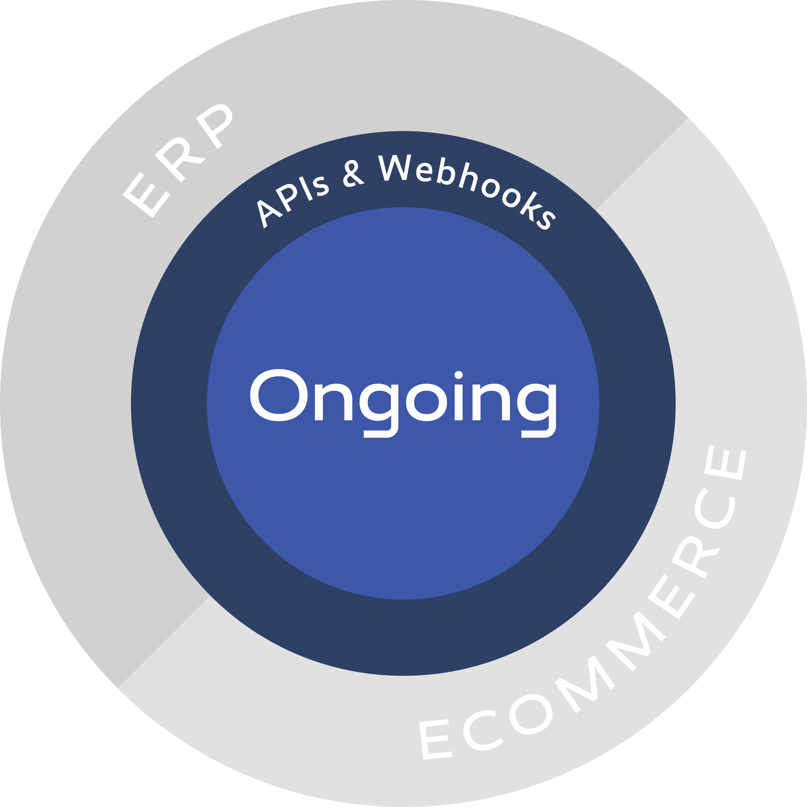

Access your warehouse data everywhere on any device
Get your log-in to Ongoing WMS. Since Ongoing WMS is a cloud service, our clients can log in from any device and location to see their warehouse data, i.e. order status, in real-time. Read more about the free-of-charge customer login and its functionalities.

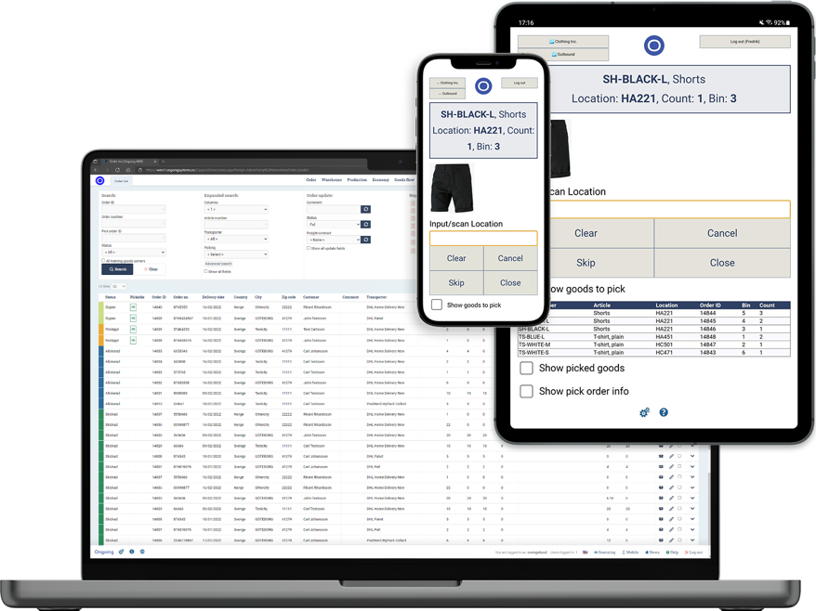

Do you lack good support for purchase orders?
Ongoing WMS helps you manage your purchasing by making it possible to create and manage your purchase orders directly in the software. This can be executed either by creating your purchase orders manually or by integrating external systems. Ongoing WMS supports the functionality to suggest what articles to order, when, and in which amount. Use Ongoing WMS to generate purchase orders.

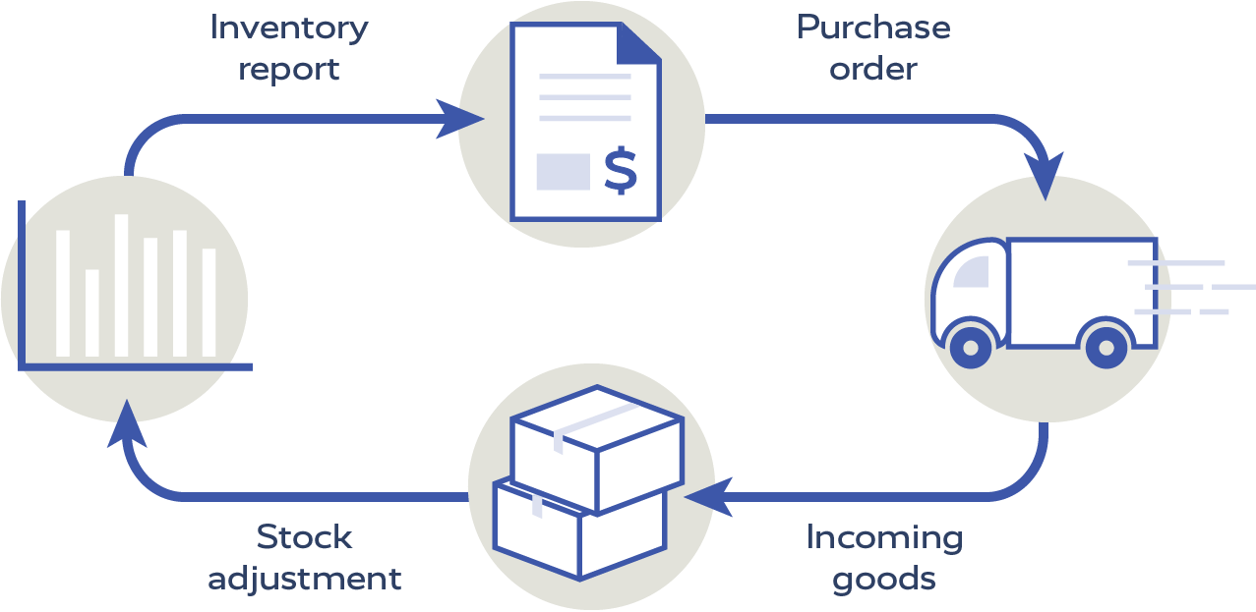

Stay updated with automatic notifications
An automatic email will tell you whenever a stock balance for an article falls below a certain level of your choice. Also, emails containing stock balances and incoming goods for all articles, including batches and expiry dates, and emails with information about your orders can automatically be sent to you. See all currently supported email notifications.


Secure WMS
​Ongoing WMS offers robust security features for 3PLs, ensuring the protection of sensitive data. By integrating with identity providers like Microsoft Entra ID, Ongoing WMS facilitates Single Sign-On (SSO), allowing users to authenticate through a centralized system. Additionally, Ongoing WMS supports Multi-Factor Authentication (MFA). Administrators can also enforce complex password policies and restrict account access based on specific IP ranges, adding further layers of security. Read more about securing access to the WMS and visit Ongoing’s Trust Center to learn how Ongoing works with IT security. Ongoing is ISO/IEC 27001:2022 certified.

